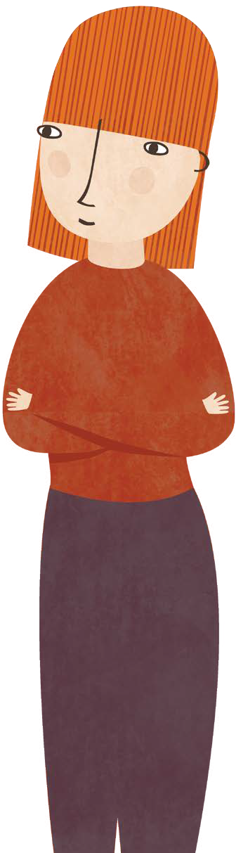
PCA Families – Child Safe Incident Form
When to use this form?

This form is used to notify us of:

- any incident, disclosure or suspicion that a child has been, or is at risk of being abused by a PCA Families director, employee, contractor or volunteer, or any other party

OR

- Breach of the PCA Families Code of Conduct regarding Child safety specifically.

This form should be used in conjunction with the PCA Families’ Child Safe Policy

Completing this form should not impact on reporting times. If a child is in immediate danger please report immediately to Victoria Police by dialling 000.

When completing this form your aim should be to provide as much information as possible. This information will be critical to any reports and may be sought at a later date if the matter is the subject of Court proceedings. All information provided will be stored securely in accordance with PCA Families Privacy Policy.

Name of Reporter: ___________________________________________ Date of Report: / /
Contact details of Reporter (phone, email, address) ___________________________________________

Incident details
Date of incident:
Time of incident:
Location of incident:
Name(s) of child/children involved:
Name(s) of parents/carer of child/children involved
Name of alleged perpetrator:
Name(s) of PCA Families director/employee/contractor/volunteer involved:
Your relationship/role to child/children involved
If you believe a child is at immediate risk of abuse phone 000.
Does the child identify as Aboriginal or Torres Strait Islander?
(Mark with an ‘X’ as applicable)
No Yes aboriginal Yes Torres Strait Islander

Please categorise the incident

Physical violence
Sexual offence
Serious emotional or psychological abuse
Serious neglect

Please describe the incident
When did it take place?
Who was involved?
What did you see/hear/observe?
Other information

Have you reported the incident to anyone else?
Child protection
Police
Another third party (please specify):

Incident reporter wishes to remain anonymous?
(Mark with an ‘X’ as applicable)
Yes |  | No

Signature: ___________________________________________ Date: _____/_____/_____
Print name: ___________________________________________

